FORM NO. 2 (Revised)

NOMINATION AND DECLARATION FORM
(For Unexempted/Exempted Establishment)
Declaration and Nomination Form under the Employees Provident Fund & Employees Pension Scheme
(Paragraph 33 and 61 (1) of the Employees Provident Fund Scheme, 1952 & Paragraph 18 of the Employees Pension Scheme, 1995)
1. Name DEBASISH PRATIHARI
(In capital letters)
2. S/o, W/o, D/o Name PURNA CHANDRA PRATIHARI
3. Date of Birth_______19-07-1976______4. Sex_Male_ 5. Date of Joining 08-06-2022______________ 6. Marital Status______Married___________7. P.F. Account No._______________________________
8. (A) Address Permanent Plot No -528, Mahatab Road, Old town, Near Narayani club, Bhubaneswar,
Odisha,Pin-751002.

(B) Address Temporary 35/2, Krishna Reddy Building, Hosur Main Road, Singasandra, Opp. EPF Office, Bangalore, Karnataka,Pin-560068
PART A (EPF)
Name of the Nominee/Nominees | Address | Nominees relation with the member | Date of Birth | Total amount of share of Accumulation in PF to be paid to each Nominee | If the Nominee is a minor, Name & Relationship & Address of the guardian who may receive the amount during minority of nominee
1 | 2 | 3 | 4 | 5 | 6
Kshitiswari Mishra | Plot No -528, Mahatab Road,Old town, Near Narayani club, Bhubaneswar, Odisha,Pin-751002, India | wife | 19-07-1978 | 100%

1. *Certified that I have no family as defined in para 2(g) of the Employee’s Provident Fund Scheme, 1952 and should I acquire a family hereafter the above nomination should be deemed as cancelled.
2. *Certified that my father/mother is/are dependent upon me.

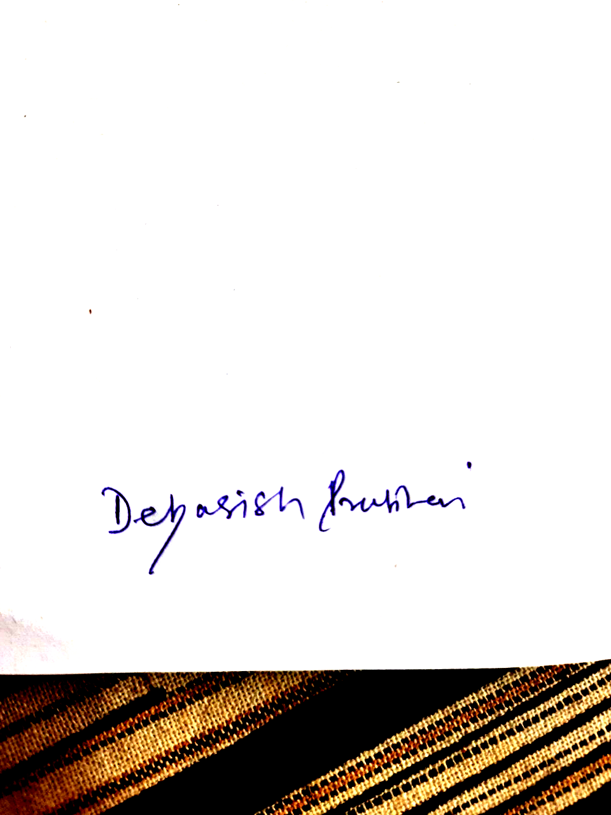

NA
*Strike out whichever is not applicable Signature or thumb impression of the subscriber
PART B (EPS) (Para 18)
I hereby furnish below particulars of the members of my family who would be eligible to receive widow children pension in the event of my death.
Name and Address of the Family member(s)

Sl. No. | Name | Address | Date of Birth | Relationship with member
1 | 2 | 3 | 4 | 5
1 | Kshitiswari Mishra | Plot No -528, Mahatab Road,Old town, Near Narayani club, Bhubaneswar, Odisha,Pin-751002, India | 19-07-1978 | wife
2 | Prateeksha Pratihari | Plot No -528, Mahatab Road,Old town, Near Narayani club, Bhubaneswar, Odisha,Pin-751002, India | 01-06-2008 | daughter
3
4
5

** Certified that I have no family as defined in Para 2 (vii) of Employees’ Pension Scheme, 1995 and should I acquire a family hereafter I shall furnish particulars thereon in the above form.
I hereby nominate the following person for receiving the monthly pension (admissible under Para 16 2(a) (i) & (ii) in event of my death without leaving any eligible family member for receiving pension.

Sl. No. | Name & address of the Nominee | Date of birth | Relationship with the member.
1 | 2 | 3 | 4
1 | Kshitiswari Mishra  Plot No -528, Mahatab Road,Old town, Near Narayani club, Bhubaneswar, Odisha,Pin-751002, India | 19-07-1978 | Wife
2
3
4
5
6

Date: - 08-06-2022
Signature or thumb impression of the subscriber

CERTIFICATE BY EMPLOYER
Certified that the above declaration and nomination has been signed/thumb impressed before me by Shri/Smt./Kum______________________________________________employed in my establishment after he/she has read the entries have read over to him/her by me and got confirmed by him/her.

Signature of the employer or other
Authorized officers of the establishment: - ____________________

Place : _____________________ Designation :- _____________________

Name and address of the factory
Dated :- _________________ Establishment or rubber stamp there of :__________

